Recycler.IQ — Tax Authority Demo Roadmap
Sprint 1 Status & Path to Demo (May 2026)
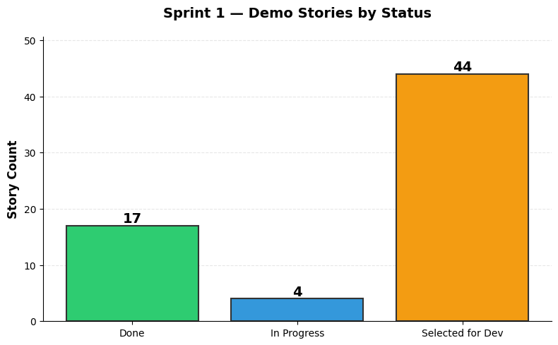

Sprint Status Summary
Status | Count | Percentage
Done | 17 | 26%
In Progress | 4 | 6%
Selected for Development | 44 | 68%
TOTAL | 65 | 100%

Project Breakdown by Status
Project | Done | In Progress | Selected for Dev | Total
RCORE | 11 | 4 | 0 | 15
RCLIENT | 6 | 0 | 22 | 28
RLINK | 0 | 0 | 17 | 17
RIQSIM | 0 | 0 | 5 | 5
TOTAL | 17 | 4 | 44 | 65

Now / Next / Later Phases

Now: Sprint 1 (Mar 29 — Apr 19, 2026)
Complete RCORE domain foundation; kickstart RCLIENT AppModeOptions; establish RLINK and RIQSIM scaffolds.
RCORE Domain Model: 15 stories (11 Done, 4 In Progress) — 75% complete. Domain entities and identity/auth types being finalized for RCLIENT integration.
RCLIENT Demo Client: 28 stories (6 Done, 22 Selected for Dev) — 21% complete. AppModeOptions and emulator deployment in scope for Sprint 1. Login UI and transaction capture queued for Sprint 2.
RLINK & RIQSIM: 22 stories (all Selected for Dev) — Phase 0 scaffolding to begin. Hardware abstraction and in-memory simulator engine are critical path items.

Next: Sprint 2 (Apr 19 — May 3, 2026)
Complete login and transaction capture UI; finalize RLINK hardware abstraction; build out RIQSIM REST API. RCORE domain fully locked. All client-facing features demo-ready by May 3.

Later: Final Push (May 3 — May 10, 2026)
Integration testing, performance optimization, bug fixes, and demo rehearsal. Target: Tax Authority demo ready by May 10.

Risks and Dependencies
Critical Path Items:
RCORE domain completion (Apr 19) — Identity/auth types must be stable before RCLIENT integration.
RCLIENT login UI (Apr 19—May 3) — PIN login and transaction UI are gating items for end-to-end demo.
RLINK hardware abstraction (Apr 19—May 3) — Device registry and request/response contract must support simulator-driven testing.
RIQSIM REST API (Apr 19—May 3) — Headless simulator state machine and API endpoints are unblocking integration.
Key Risks:
RLINK complexity — Mitigate by starting with simple in-memory device registry; defer Phase 1 (sync, observability) to post-demo.
RIQSIM race conditions — Use async/await and message queue patterns; unit test state machine extensively.
RCLIENT UI responsiveness — Profile with 100 concurrent transactions; optimize data binding and rendering.
Domain model schema lock-in — Finalize RCORE contracts by Apr 19; no breaking changes after.

Success Criteria
By May 10, 2026 (Tax Authority Demo):
RCLIENT MAUI app deploys to Windows emulator
Tax cashier can log in with PIN
System accepts cash input via simulator device
Real-time transaction progress visible on screen
Change dispensing calculation runs and displays
No unhandled exceptions during demo scenario
Scenario completes in under 3 minutes end-to-end

